Chhay Lay Heng

CS 4141.115

Oct 20, 2023

Experiment 1 Post-Lab

Partners: Korbin Schulz and Bennett Quigley

Y1 = (A • B) + (C • D)’

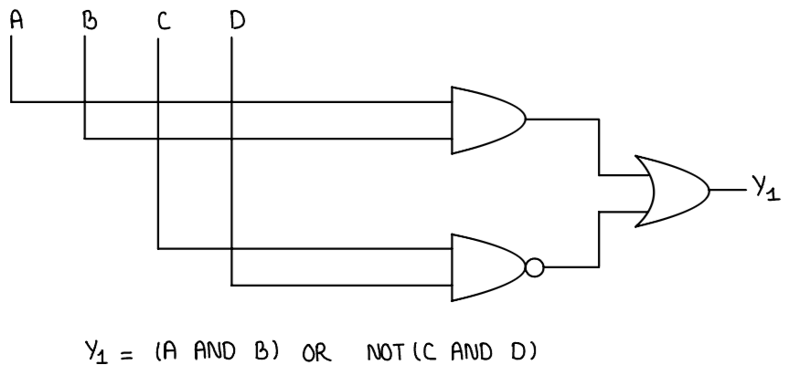

Y2 = (A’ • B’) + (C • D)

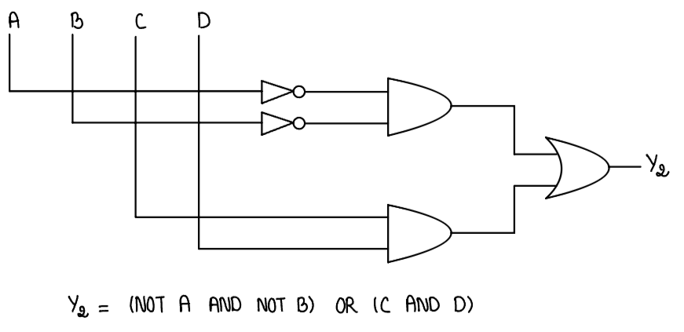

Y3 = (A • B)’ + (C’ • D’)

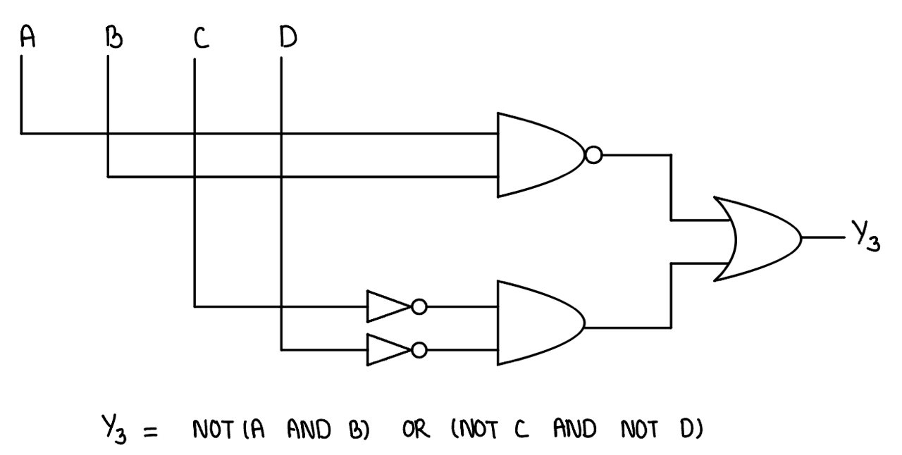

Y4 = (A ⊕ B) + (C ⊕ D)

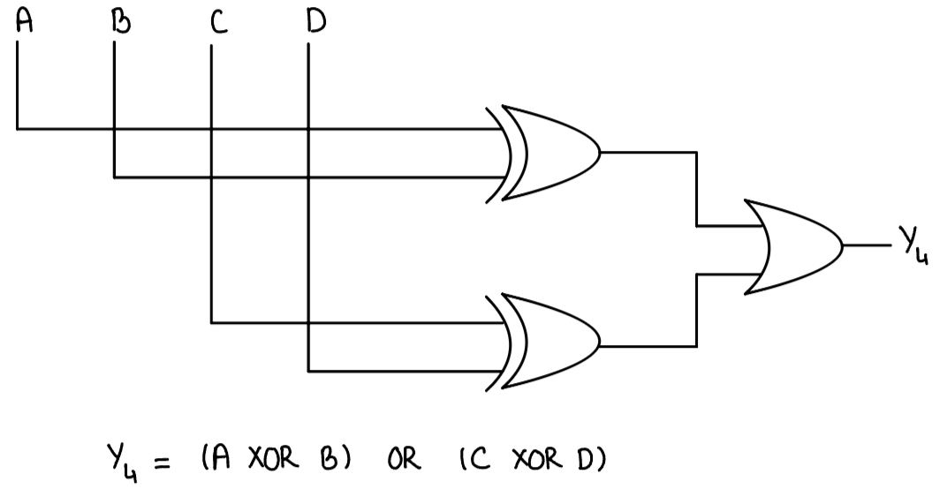

**Truth Table**

|  |  |  |  |  |  |  |  |
| --- | --- | --- | --- | --- | --- | --- | --- |
| A | B | C | D | **Y1** | **Y2** | **Y3** | **Y4** |
| 0 | 0 | 0 | 0 | **1** | **1** | **1** | **0** |
| 0 | 0 | 0 | 1 | **1** | **1** | **1** | **1** |
| 0 | 0 | 1 | 0 | **1** | **1** | **1** | **1** |
| 0 | 0 | 1 | 1 | **0** | **1** | **1** | **0** |
| 0 | 1 | 0 | 0 | **1** | **0** | **1** | **1** |
| 0 | 1 | 0 | 1 | **1** | **0** | **1** | **1** |
| 0 | 1 | 1 | 0 | **1** | **0** | **1** | **1** |
| 0 | 1 | 1 | 1 | **0** | **1** | **1** | **1** |
| 1 | 0 | 0 | 0 | **1** | **0** | **1** | **1** |
| 1 | 0 | 0 | 1 | **1** | **0** | **1** | **1** |
| 1 | 0 | 1 | 0 | **1** | **0** | **1** | **1** |
| 1 | 0 | 1 | 1 | **0** | **1** | **1** | **1** |
| 1 | 1 | 0 | 0 | **1** | **0** | **1** | **0** |
| 1 | 1 | 0 | 1 | **1** | **0** | **0** | **1** |
| 1 | 1 | 1 | 0 | **1** | **0** | **0** | **1** |
| 1 | 1 | 1 | 1 | **1** | **1** | **0** | **0** |